ZRT-100A Linear High-Speed Sleeve Labeling Machine
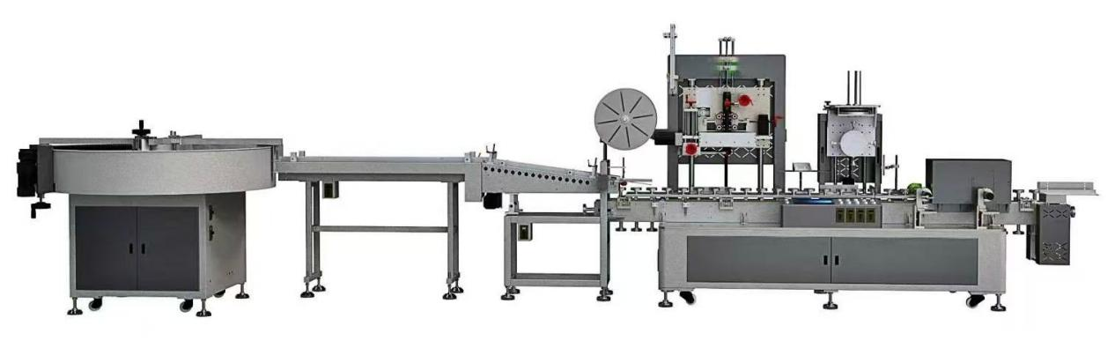
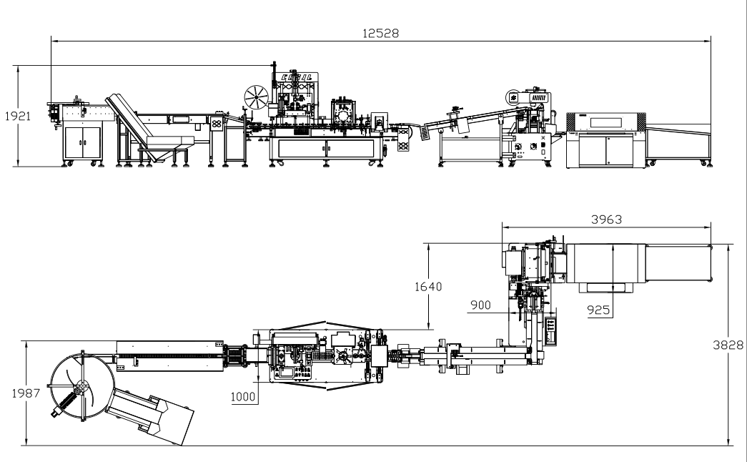
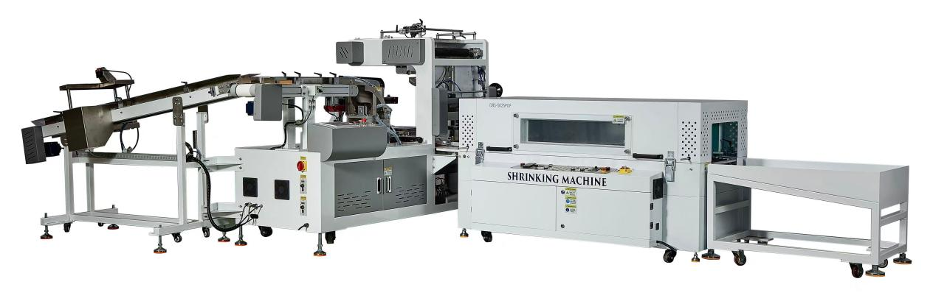Equipment Layout：
Basic Uses：
Mainly used for shrink films and paper card packaging for various tapes

Summarize：
Thank you very much for your support.

- Due to your correct choice, you now have a safe, practical, efficient and novel fully automatic adhesive tape high-speed labeling and packaging equipment.
- This equipment is mainly used for wrapping circular objects such as tapes with shrink film. It can also be used in conjunction with a constant-temperature (PVC) shrinkage oven to achieve complete and excellent shrinkage effects on the packaged items. This equipment has a wide range of applications, high economic benefits, and is easy to operate. The packaging materials applicable to this equipment are PVC films. Compared to traditional manual packaging, it significantly reduces packaging costs. The products packaged by this equipment have the characteristics of neat and beautiful appearance, compactness without dispersion, ensuring product quality and suitability for long-distance transportation.
- The entire machine is mainly composed of the body, electrical system and gas supply system. It is a relatively advanced new packaging equipment in the current film lamination, sealing and heat shrink packaging machines. It possesses multiple patent intellectual property rights.

Main Technical Parameters:
Power supply | AC380/AC220 50～60HZ
total power | 15KW
Power of the hot air gun | 8.8KW(4 pieces)
Maximum package diameter | 50-100MM
packaging speed | 100-120PCS
Height of the conveying platform | 780+50MM(customized)
working pressure | 5～7kgf/cm²
contour size of the unit(s)(L*W*H) | 6050*930*2000MM
total weight | 1800kg

Configuration Parameters:
Model | ZRT-100A
touch screen | NDSRTI
Turntable servo | HCFA
Turntable drive | HCFA
Film feed servo | HCFA
film feeder | HCFA
Film cutting servo | HCFA
Film cutting drive | HCFA
Absorption servo | HCFA
Suction drive | HCFA
Reducer | SMT
Splitter | JUJIU
PLC Controller | PLC
Air Switch | CHINT
Contactor | Schneider
Switching Mode Power Supply | Mingwei
electric machinery | MAILI
Photoelectric switch | BOJKE
Solid-state relay | yangming
relay | IDEC
Thermostat | Taie
frequency converter | cost
Button switch | Schneider
Cylinder | Star
filter | STNC
Solenoid valve | STNC
真空电磁阀 | MAC
Auto switch | AirTAC
vacuum generator | Pheb
Bearing | NSK
frame | Imported powder spraying

